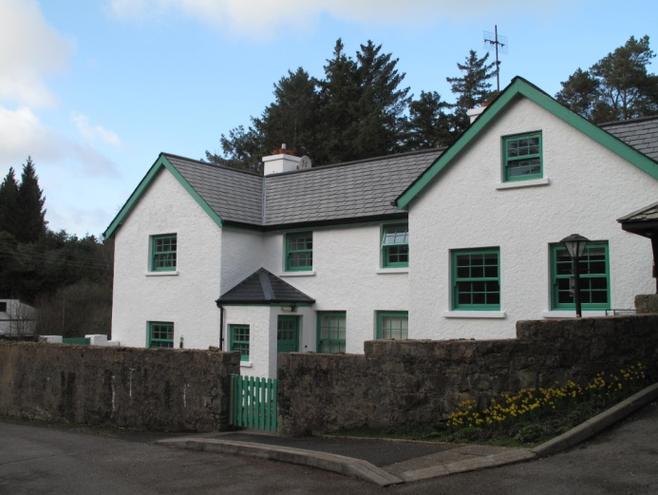Glenveagh National Park

Education Centre

Junior Cert Ecology Workbook

Habitat Study

Name _____________________________

School _____________________________

Date _____________________________

Plan for the Day:

- Arrive and brief introduction to the day and equipment

- Map of habitat and Environmental Factors

- Collect 5 Plant samples and identify

- Collect 5 Animal samples and identify - using a variety of methods.

Lunch Break
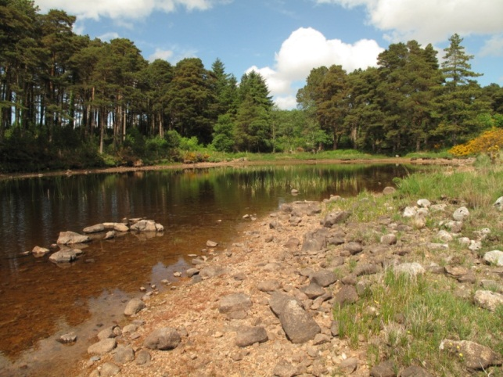

- Quadrat and Line Transect Experiments

- Discussion and write up workbooks

- Evaluation of the Day

Map of the Habitat:

Draw a plan view of the area. Write a brief description answering some of the following questions:
What is the name of the area and where is it located?
Which way is the area facing (aspect)? Is it level or not (steepness)?
Is it an open are or surrounded (exposure)?
Make a legend for key features and mark the direction North using a compass.

Answers to questions:

Environmental Factors

Use the equipment provided to record the following:( Record 3 )

Environmental Factor | Result | Sketch of Equipment Used And Description
Air temperature

Soil temperature

Soil pH

Light intensity

Percentage of water in the soil

Identify and record features of five plants:

Plant Name | Where Found | Adaptation | Interdependence | Competition | Sketch

Notes:

Animal/ Invertebrate sampling:

Experiments with pooters, sweep nets, pitfall traps and beating trays.

Identify, record and sketch 5 samples.

Animal Name | Where Found | Adaptation | Interdependence | Competition | Sketch

Notes on methods used and possible sources of error:

Distribution of Plants in the Habitat

Plant Frequency

Use the quadrat, identification material and a pencil. Throw the pencil anywhere within your site. Set one corner of the quadrat where the pen landed keeping the quadrat parallel to the boundary of your site. You will do this ten times and record Frequency.

Step 1: Throw the quadrat and record the presence or absence of each of your 5 plants inside the quadrat in the frequency table below, with a tick if it is present. Add the names of any new plants that you find that you didn’t identify earlier if time allows.

Step 3: Repeat 10 throws of the quadrat, making recordings the table.

Frequency Table | Quadrat No
Plant Name | 1 | 2 | 3 | 4 | 5 | 6 | 7 | 8 | 9 | 10 | %Frequency

To calculate the totals: Percentage Frequency Calculations:

To calculate % frequency use this formula:

Number of quadrats containing the plant
total no. of quadrats x 100/1

Results Graphs

Draw a graph of your results, with % frequency on the Y axis and plants on the X axis

Q. What do these graphs tell you about the distribution of plants in the habitat?

Q. How can these results be linked to Environmental Factors and Adaptations?

Line Transect:

Lay the marked rope across an area of change in the habitat. Stake the rope at each end. Record what plant (or animal) is touching or under the rope at each 1m station.
What changes are there? What do these results tell you about this area of the ecosystem? What Abiotic Factors are influencing your findings?

Labelled Diagram of Transect:

Results:

Station Number at 1m intervals | Name of plant (or animal) touching or under the mark
1

2

3

4

5

6

7

8

9

10

Food Chains and Food Webs:

Record 3 Food chains you have seen in the habitat
Fox
Frog
Eagle
Midge

Draw a Food Web :

What are your conclusions from this study?

