Glenveagh National Park

Education Centre

Leaving Cert Ecology Workbook

Study of an Ecosystem

Name _____________________________

School _____________________________

Date _____________________________

Plan for the Day:

- Arrival, introduction, and run-down of the day

- Begin walk on Derrylahan Nature Trail

- Introduction to park, ongoing conservation work, & ecology equipment

- Return to Bridge House Education Centre for lunch

Lunch Break

- Map of habitat & environmental factors

- Collect 5 plant samples & 5 animal samples and identify
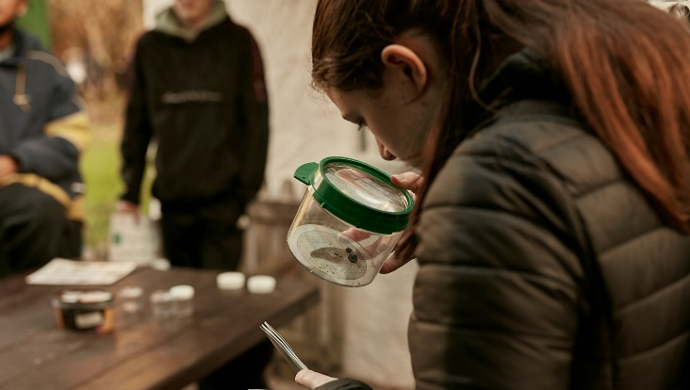
- Qualitative & Quantitative analyses

- Write up & discussion

Map of the Ecosystem and its Habitats:

Draw a plan view of the area. Write a brief description answering some of the following questions:
What is the name of the area and where is it located?
Which way is the area facing (aspect)? Is it level or not (steepness)?
Is it an open are or surrounded (exposure)?
Make a legend for key features and mark the direction North using a compass.

Answers to questions:

Abiotic Factors (non living)
including Climatic and Edaphic (soils) factors:

Use the equipment provided to record the following:( Record 3 )

Abiotic factor | Apparatus used and Diagram | How it was used
Air temperature

Soil temperature

Soil pH

Light intensity

Link these to plant/animal adaptations:

Abiotic factor | Plant/animal | Adaptation
1.

2.

3.

Identify and record features of five plants:

Mark the location of each on the map drawn using the key P1, P2....

Plant Name | Where Found | Adaptation | Competition | Sketch

Notes:

Animal/ Invertebrate sampling:

Experiments with pooters, sweep nets, pitfall traps, small mammal traps and beating trays, and cryptozoic traps.

Identify, record and sketch 5 samples. Mark the location of each on the map using the key A1, A2 etc.

Animal Name | Where Found | Adaptation | Competition | Sketch

Notes on methods used and possible sources of error:

Qualitative and Quantitative Study

Plant Frequency and Percentage Cover:

Use the quadrat, identification material and a pencil. Throw the pencil anywhere within your site. Set one corner of the quadrat where the pen landed keeping the quadrat parallel to the boundary of your site. You will do this ten times and record two sets of information – one for Frequency and one for Percentage Cover.

Step 1: Throw the quadrat and record the presence or absence of each of your 5 plants inside the quadrat in the frequency table below, with a tick if it is present. Add the names of any new plants that you find that you didn’t identify earlier if time allows.

Step 2: After each throw, record the percentage cover of each of your 5 plants in the second table. Count the number of times each plant touches the top right hand corner of each small grid within the quadrat. *A full size quadrat would have 100 squares so multiply your count by 4*

Step 3: Repeat 10 throws of the quadrat, making recordings in each of the two tables.

Frequency Table | Quadrat No
Plant Name | 1 | 2 | 3 | 4 | 5 | 6 | 7 | 8 | 9 | 10 | %Frequency

Percentage Cover Table | Quadrat No
Plant Name | 1 | 2 | 3 | 4 | 5 | 6 | 7 | 8 | 9 | 10 | %Cover

To calculate the totals:

Percentage Frequency Calculations:

To calculate % frequency use this formula:

Number of quadrats containing the plant 100
Total no. of quadrats x 1

Percentage Cover Calculations:

To calculate the % cover, use this formula:

No. of points covered x 100

Total no. of grid points 1

Results Graphs

Draw a graph of your results, with % frequency on the Y axis and plants on the X axis

Graphs Continued:

Draw a graph with the % cover results, in a similar way:

What do these graphs tell you about the distribution of plants in the habitat?

How can these results be linked to Abiotic Factors and Adaptations?

Line Transect:
Study the changes in vegetation - compare with the abiotic factors to see adaptations

Lay the marked rope across an area of change in the habitat. Stake the rope at each end. Record what plant (or animal) is touching or under the rope at each 1m station.

Labelled Diagram of Transect:

Results:

Station Number at 1m intervals | Name of plant (or animal) touching or under the mark
1

2

3

4

5

6

7

8

9

10

What do these results tell you about this area of the ecosystem? What Abiotic Factors are influencing your findings?

Discussion Notes :

Use this space to record significant observations, interesting points, or anything else that arises from the conversation. Make drawings and diagrams to help you remember what you saw and did.

- Adaptation of Species - structural or behavioural:

- Food chains and webs:

- Energy Flow and Pyramid of Numbers:

- Abiotic factors (and biotic) affecting the results of your study:

What did your results tell you about the ecosystem? What sources of error were there? What else could be investigated? What are your conclusions?

